Hazel Prior
A concert of Harp Music and Songs

with wine and cheese social to follow

ROADWATER VILLAGE HALL
FRIDAY 4 OCTOBER
6.00 p.m.

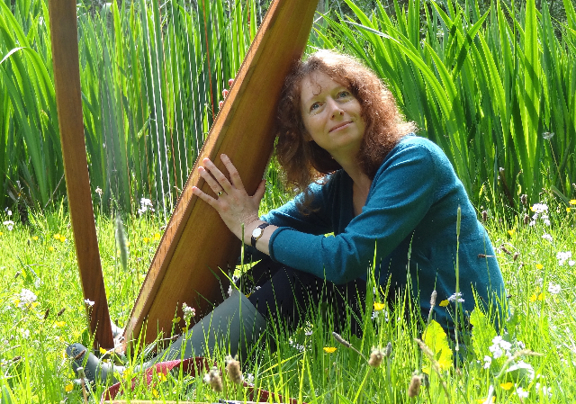
HAZEL PRIOR is a locally based harpist living on Exmoor with her husband and a huge ginger cat. She has toured extensively with singing groups and has played at many festivals and theatres. Her repertoire includes Celtic, classical, traditional, popular and medieval harp music and songs. She has published stories in literary magazines and more recently a book “Ellie and the Harp Maker” (Bantam Press), signed copies of which will be available to purchase at the concert.

Tickets £6 (includes a glass of wine or soft drink with selection of cheese/nibbles) available at Roadwater village shop (01984 640296) and the Valiant Soldier. For further information email cbsroadwater@gmail.com.

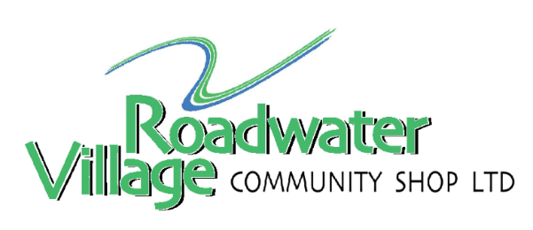
proceeds towards shop refurbishment

